**C:\Users\Heather\AppData\Local\Microsoft\Windows\Temporary Internet Files\Content.IE5\7MQAZRH6\MCj02327230000[1].wmfWave Measurements**

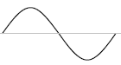

One full wave (cycle)

Wave train – two or more waves  
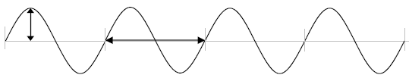

Amplitude – measures the energy of a transverse wave   
    a) measured from the equilibrium position to the top of a crest or the bottom   
        of a trough (see vertical arrow)  
Wavelength – length of a single wave cycle (horizontal arrow double sided arrow)  
  
There are 4 waves in this wave train

**Wave 1**

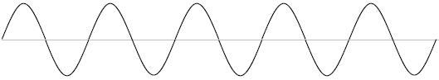  
a) How many waves are there in this wave train? _____

b) Wavelength ______ cm   c) Amplitude _______ cm  
  
**Wave 2**  
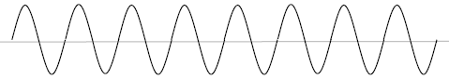

a) How many waves are there in this wave train? _____  
  
b) Wavelength ______ cm   c) Amplitude _______ cm

**Wave 3**  
http://www.stmary.ws/physics/home/hand_3/handouts/WaveWo5.gif  
a) How many waves are there in this wave train? _____  
  
b) Wavelength ______ cm   c) Amplitude _______ cm

**Wave 4**  
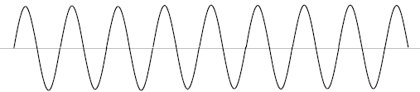  
a) How many waves are there in this wave train? _____  
  
b) Wavelength ______ cm   c) Amplitude _______ cm  
  
**Wave 5**  
http://www.stmary.ws/physics/home/hand_3/handouts/WaveWo7.gif  
a) How many waves are there in this wave train? _____  
  
b) Wavelength ______ cm   c) Amplitude _______ cm

**Wave 6**  
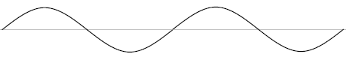  
a) How many waves are there in this wave train? _____  
  
b) Wavelength ______ cm  c) Amplitude _______ cm  
  
**Wave 7**  
If this entire wave train is 30 meters long what is the wavelength of this wave?

